1-World Wide Web

What is a World Wide Web?
# Source: AI Source: Provided by: [Data Path: Persons Table -> ID Column: 1, Name_En Column: Motasem Essam] -> From: [ChatGPT] on [12/18/2025]
The World Wide Web is a system of interlinked documents and resources (Web Resources) accessed through the internet using web browsers.

Simple Explanation:
# Source: AI Source: Provided by: [Data Path: Persons Table -> ID Column: 1, Name_En Column: Motasem Essam] -> From: [ChatGPT] on [12/18/2025]
The Web is a collection of websites, pages, images, videos, and other content you can view using browsers like Chrome, Firefox, or Safari.

How It Works:
# Source: AI Source: Provided by: [Data Path: Persons Table -> ID Column: 1, Name_En Column: Motasem Essam] -> From: [ChatGPT] on [12/18/2025]
- The Web runs on the internet but is just one of many services on it.
- Uses protocols like HTTP/HTTPS to request and display web pages.
- Web pages are written in HTML (HyperText Markup Language).
- You navigate the Web by clicking links or entering URLs.

Examples of Web Resources
# Source: AI Source: Provided by: [Data Path: Persons Table -> ID Column: 1, Name_En Column: Motasem Essam] -> From: [ChatGPT] on [12/18/2025]
Web resources are all the content and data (like pages, images, videos, files, and code) you access and interact with on websites.

- Web pages — Text, images, and formatting you see in a browser
- Images — Photos, graphics, icons embedded in pages
- Videos — Streaming or downloadable video content (YouTube, Vimeo)
- Audio — Music, podcasts, sound effects
- Documents — PDFs, Word files, spreadsheets available for download or viewing
- Scripts — Code like JavaScript that runs in your browser to make pages interactive
- Stylesheets (CSS) — Files that define the look and layout of web pages
- APIs (Application Programming Interfaces) — Endpoints that deliver data or services to web apps
- Forms and data input — Elements that let users submit information
- Downloadable files — Software installers, eBooks, images, etc.
- Web applications — Full interactive apps like email clients or online editors running in the browser

Difference Between Internet and Web
# Source: AI Source: Provided by: [Data Path: Persons Table -> ID Column: 1, Name_En Column: Motasem Essam] -> From: [ChatGPT] on [12/18/2025]

Internet | World Wide Web (Web)
Global network of devices | Collection of websites and pages
Infrastructure (hardware + protocols) | Content accessible over the internet
Supports many services (email, FTP, games) | Primarily for browsing and interacting with content

Examples of Web Content
# Source: AI Source: Provided by: [Data Path: Persons Table -> ID Column: 1, Name_En Column: Motasem Essam] -> From: [ChatGPT] on [12/18/2025]
- Wikipedia pages
- Online news sites
- Social media platforms
- E-commerce stores

Summary
# Source: AI Source: Provided by: [Data Path: Persons Table -> ID Column: 1, Name_En Column: Motasem Essam] -> From: [ChatGPT] on [12/18/2025]
The World Wide Web is the system of websites and pages you access via the internet using a browser.

2-Web Browser

✅ What is a Web Browser?
# Source: AI Source: Provided by: [Data Path: Persons Table -> ID Column: 1, Name_En Column: Motasem Essam] -> From: [ChatGPT] on [12/18/2025]
A Web Browser is a software application that lets you access and view websites on the Internet.
It takes web content (HTML, CSS, JavaScript) from a web server and displays it visually so you can interact with it.

🧠 Think of it like:
# Source: AI Source: Provided by: [Data Path: Persons Table -> ID Column: 1, Name_En Column: Motasem Essam] -> From: [ChatGPT] on [12/18/2025]
A window to the internet — you type in a website address, and the browser shows you the site.

🧭 Popular Web Browsers
# Source: AI Source: Provided by: [Data Path: Persons Table -> ID Column: 1, Name_En Column: Motasem Essam] -> From: [ChatGPT] on [12/18/2025]
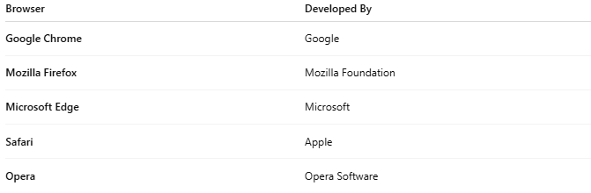
Browser | Developed By
Google Chrome | Google
Mozilla Firefox | Mozilla Foundation
Microsoft Edge | Microsoft
Safari | Apple
Opera | Opera Software

🛠️ What a Web Browser Does:
# Source: AI Source: Provided by: [Data Path: Persons Table -> ID Column: 1, Name_En Column: Motasem Essam] -> From: [ChatGPT] on [12/18/2025]
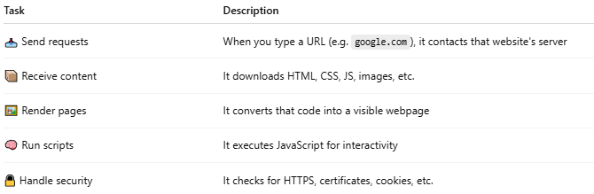
Task | Description
📥 Send requests | When you type a URL (e.g. google.com), it contacts that website's server
📦 Receive content | It downloads HTML, CSS, JS, images, etc.
🖼️ Render pages | It converts that code into a visible webpage
🧠 Run scripts | It executes JavaScript for interactivity
🔒 Handle security | It checks for HTTPS, certificates, cookies, etc.

📚 Example: What Happens When You Visit https://example.com
# Source: AI Source: Provided by: [Data Path: Persons Table -> ID Column: 1, Name_En Column: Motasem Essam] -> From: [ChatGPT] on [12/18/2025]
- The browser sends a request to the server at example.com
- The server responds with HTML/CSS/JS files
- The browser renders that into a styled, interactive webpage
- If you click a button or submit a form, the browser sends data back to the server

🖥️ What You Can Do with a Browser
# Source: AI Source: Provided by: [Data Path: Persons Table -> ID Column: 1, Name_En Column: Motasem Essam] -> From: [ChatGPT] on [12/18/2025]
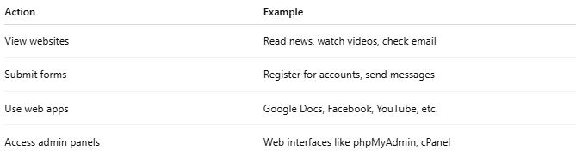
Action | Example
View websites | Read news, watch videos, check email
Submit forms | Register for accounts, send messages
Use web apps | Google Docs, Facebook, YouTube, etc.
Access admin panels | Web interfaces like phpMyAdmin, cPanel

✅ Summary
# Source: AI Source: Provided by: [Data Path: Persons Table -> ID Column: 1, Name_En Column: Motasem Essam] -> From: [ChatGPT] on [12/18/2025]
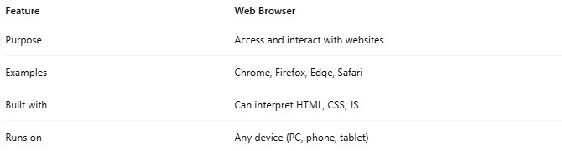
Feature | Web Browser
Purpose | Access and interact with websites
Examples | Chrome, Firefox, Edge, Safari
Built with | Can interpret HTML, CSS, JS
Runs on | Any device (PC, phone, tablet)

Would you like a visual breakdown of how a browser talks to a web server?

3-Web Interface

✅ What is a Web Interface?
# Source: AI Source: Provided by: [Data Path: Persons Table -> ID Column: 1, Name_En Column: Motasem Essam] -> From: [ChatGPT] on [12/18/2025]
A Web Interface is a visual interface that runs in a web browser and allows users to interact with an application, system, or service — through HTML pages instead of software installed on their computer.
It's the front-end (what users see and use) of a system, displayed in a browser like Chrome, Firefox, or Safari.

🧠 Think of It Like:
# Source: AI Source: Provided by: [Data Path: Persons Table -> ID Column: 1, Name_En Column: Motasem Essam] -> From: [ChatGPT] on [12/18/2025]
A remote control panel that you access through the web — with buttons, forms, tables, etc.

🔍 Examples of Web Interfaces:
# Source: AI Source: Provided by: [Data Path: Persons Table -> ID Column: 1, Name_En Column: Motasem Essam] -> From: [ChatGPT] on [12/18/2025]
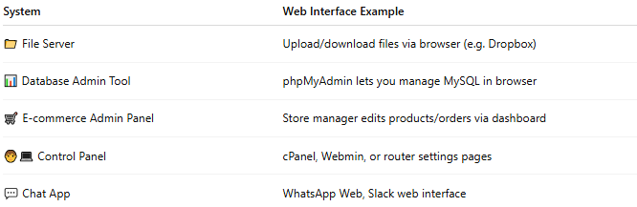
System | Web Interface Example
📁 File Server | Upload/download files via browser (e.g. Dropbox)
📊 Database Admin Tool | phpMyAdmin lets you manage MySQL in browser
🛒 E-commerce Admin Panel | Store manager edits products/orders via dashboard
🧑‍💻 Control Panel | cPanel, Webmin, or router settings pages
💬 Chat App | WhatsApp Web, Slack web interface

🛠️ What It’s Made Of:
# Source: AI Source: Provided by: [Data Path: Persons Table -> ID Column: 1, Name_En Column: Motasem Essam] -> From: [ChatGPT] on [12/18/2025]
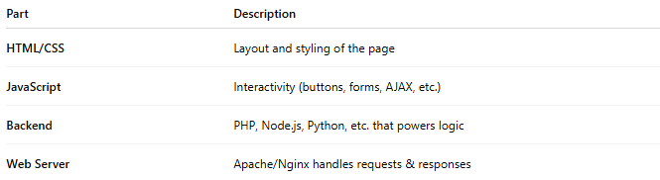
Part | Description
HTML/CSS | Layout and styling of the page
JavaScript | Interactivity (buttons, forms, AJAX, etc.)
Backend | PHP, Node.js, Python, etc. that powers logic
Web Server | Apache/Nginx handles requests & responses

📦 Benefits of a Web Interface
# Source: AI Source: Provided by: [Data Path: Persons Table -> ID Column: 1, Name_En Column: Motasem Essam] -> From: [ChatGPT] on [12/18/2025]
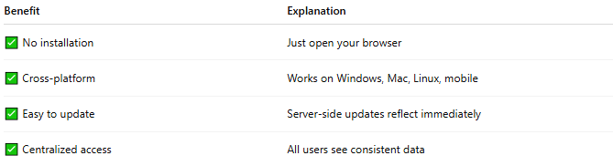
Benefit | Explanation
✅ No installation | Just open your browser
✅ Cross-platform | Works on Windows, Mac, Linux, mobile
✅ Easy to update | Server-side updates reflect immediately
✅ Centralized access | All users see consistent data

🖼 Example in Practice
# Source: AI Source: Provided by: [Data Path: Persons Table -> ID Column: 1, Name_En Column: Motasem Essam] -> From: [ChatGPT] on [12/18/2025]
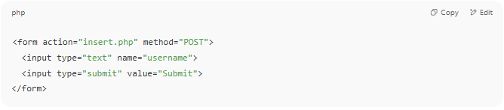
<form action="insert.php" method="POST">
<input type="text" name="username">
<input type="submit" value="Submit">
</form>

This form is part of a web interface to send data to a server.

✅ Summary
# Source: AI Source: Provided by: [Data Path: Persons Table -> ID Column: 1, Name_En Column: Motasem Essam] -> From: [ChatGPT] on [12/18/2025]
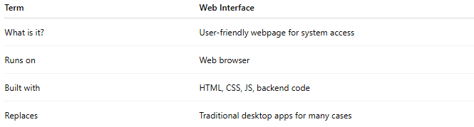
Term | Web Interface
What is it? | User-friendly webpage for system access
Runs on | Web browser
Built with | HTML, CSS, JS, backend code
Replaces | Traditional desktop apps for many cases

Would you like an example web interface made for a file uploader, database viewer, or admin dashboard?

4-what is url
# Source: AI Source: Provided by: [Data Path: Persons Table -> ID Column: 1, Name_En Column: Motasem Essam] -> From: [ChatGPT] on [12/18/2025]
A URL (Uniform Resource Locator) is the address you type into your browser to visit a website or access a specific resource on the internet.

Example:
# Source: AI Source: Provided by: [Data Path: Persons Table -> ID Column: 1, Name_En Column: Motasem Essam] -> From: [ChatGPT] on [12/18/2025]
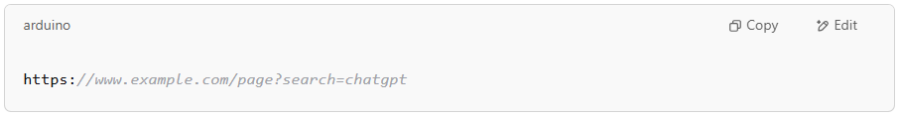
https://www.example.com/page?search=chatgpt

Parts of a URL:
# Source: AI Source: Provided by: [Data Path: Persons Table -> ID Column: 1, Name_En Column: Motasem Essam] -> From: [ChatGPT] on [12/18/2025]
- Protocol: https:// – Tells the browser how to connect.
- Domain: www.example.com – The address of the website.
- Path: /page – Specific page or resource on the site.
- Query string: ?search=chatgpt – Optional parameters sent to the server.
If you think of a website like a house:
- The URL is the full address.
- The domain is the street address.
- The path is the room inside the house.

break down a specific URL
# Source: AI Source: Provided by: [Data Path: Persons Table -> ID Column: 1, Name_En Column: Motasem Essam] -> From: [ChatGPT] on [12/18/2025]
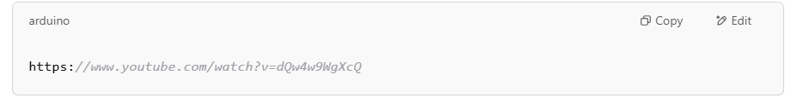
https://www.youtube.com/watch?v=dQw4w9WgXcQ

🧩 1. Protocol → https://
# Source: AI Source: Provided by: [Data Path: Persons Table -> ID Column: 1, Name_En Column: Motasem Essam] -> From: [ChatGPT] on [12/18/2025]
- Tells the browser what method to use to access the resource.
- https = Secure version of http, using encryption.

🌐 2. Domain → www.youtube.com
# Source: AI Source: Provided by: [Data Path: Persons Table -> ID Column: 1, Name_En Column: Motasem Essam] -> From: [ChatGPT] on [12/18/2025]
- The website’s address.
- This is what DNS (Domain Name System) translates into an IP address to find the server.

📁 3. Path → /watch
# Source: AI Source: Provided by: [Data Path: Persons Table -> ID Column: 1, Name_En Column: Motasem Essam] -> From: [ChatGPT] on [12/18/2025]
- Points to a specific page or resource on the site.
- In this case, it’s YouTube’s video player page.

❓ 4. Query String → ?v=dQw4w9WgXcQ
# Source: AI Source: Provided by: [Data Path: Persons Table -> ID Column: 1, Name_En Column: Motasem Essam] -> From: [ChatGPT] on [12/18/2025]
- Comes after the ? symbol.
- A key-value pair:
  - v is the key (like a label)
  - dQw4w9WgXcQ is the value (the actual video ID)
- YouTube uses this to know which video to play.

🔄 What Happens Behind the Scenes:
# Source: AI Source: Provided by: [Data Path: Persons Table -> ID Column: 1, Name_En Column: Motasem Essam] -> From: [ChatGPT] on [12/18/2025]
- Browser reads the URL and sees it needs to use https.
- DNS lookup happens – converts www.youtube.com into an IP address.
- Browser connects to the server at that IP using the HTTPS protocol.
- Sends a request to /watch with the query v=dQw4w9WgXcQ.
- Server responds with the HTML, JavaScript, etc. for the video page.
- Browser displays the page, loads the video, and voilà – you’re watching!

